The wandering Wise Men

If you are looking for an alternative to the Elf on the Shelf look no more, the Wandering Wise Men are here to follow a star and take a journey with you. Each day they share a piece of the real story of Christmas with you or suggest an Act of Random Kindness you could do in the true spirit of the season. And occasionally they get up to something mischievous.

You can buy 3 Wise Men, like these from Amazon
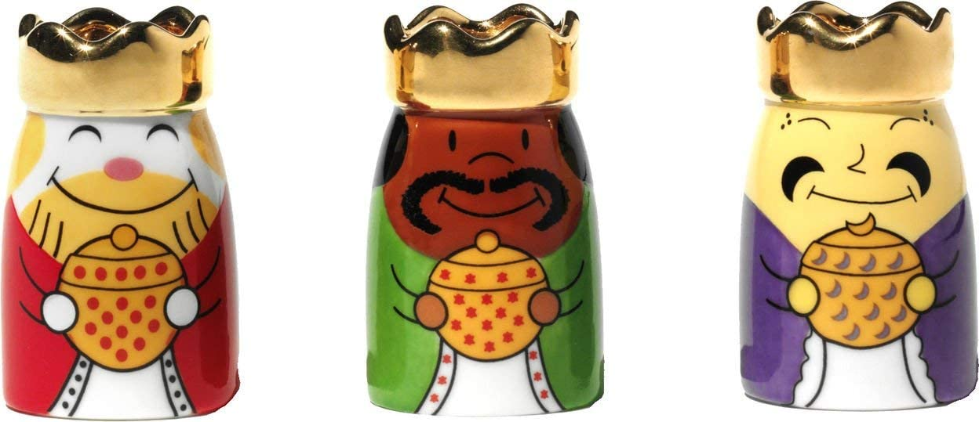
Or make some yourself like these
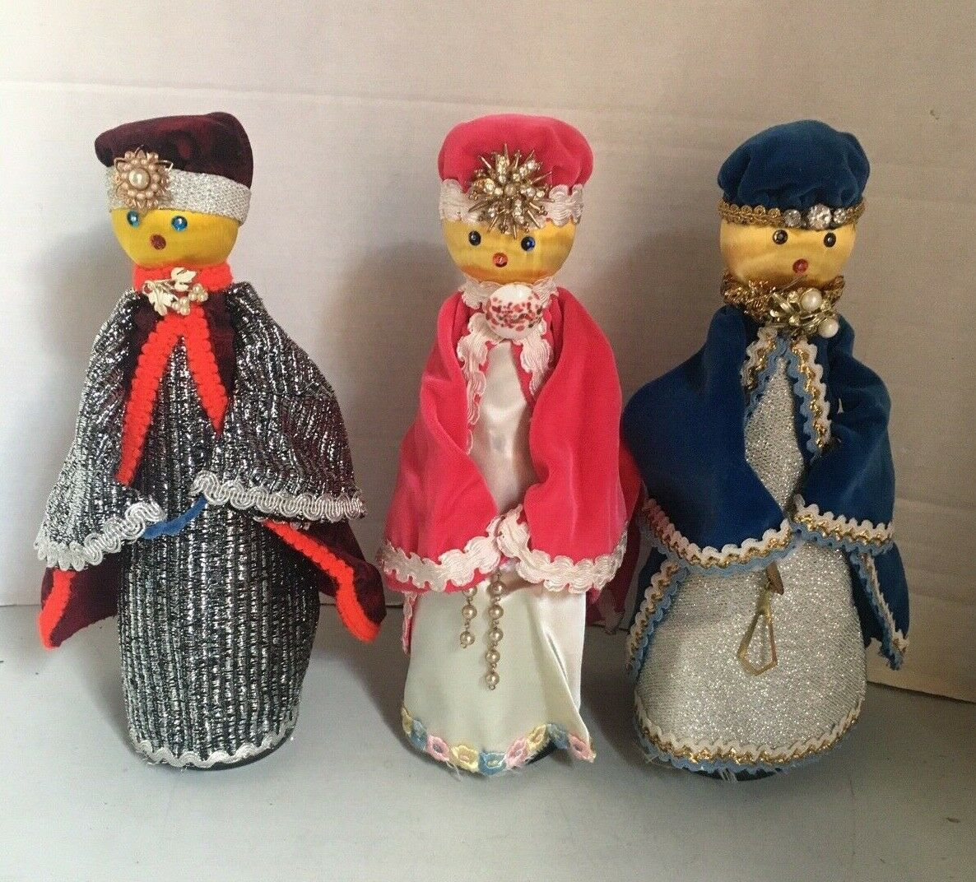
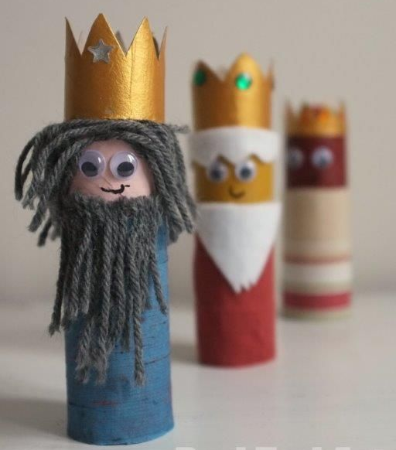
It doesn’t really matter what your Wise Men look like . What matters is the Wise Men are on the move on their journey.

On odd days from December 1st the Wise Men share the Christmas Story while travelling around your house. On even days they get a little mischievous and suggest an act of random kindness you could do.

1st Dec A long time ago, there was a lady called Mary. One day, while Mary was doing the washing up, she saw a bright light. She had to cover her eyes because it was so bright.

3rd Dec A long time ago, there was a lady called Mary. One day, while Mary was doing the washing up, she saw a bright light. She had to cover her eyes because it was so bright.The bright light was an angel. Angels are very beautiful creatures who live in Heaven and work for God.

5th Dec A long time ago, there was a lady called Mary. One day, while Mary was doing the washing up, she saw a bright light. She had to cover her eyes because it was so bright.The bright light was an angel. Angels are very beautiful creatures who live in Heaven and work for God. The angel gave Mary a message from God – he said she was going to have a baby.
Soon Mary’s tummy started to get bigger as the baby in her tummy started to grow.

7th Dec A long time ago, there was a lady called Mary. One day, while Mary was doing the washing up, she saw a bright light. She had to cover her eyes because it was so bright.The bright light was an angel. Angels are very beautiful creatures who live in Heaven and work for God. The angel gave Mary a message from God – he said she was going to have a baby.
Soon Mary’s tummy started to get bigger as the baby in her tummy started to grow.Just a few weeks before her baby was ready to be born, the king told all the people in the country that they had to travel to the place where their family was from. This meant Mary and Joseph had to go on a journey.

9th Dec A long time ago, there was a lady called Mary. One day, while Mary was doing the washing up, she saw a bright light. She had to cover her eyes because it was so bright.The bright light was an angel. Angels are very beautiful creatures who live in Heaven and work for God. The angel gave Mary a message from God – he said she was going to have a baby.
Soon Mary’s tummy started to get bigger as the baby in her tummy started to grow.Just a few weeks before her baby was ready to be born, the king told all the people in the country that they had to travel to the place where their family was from. This meant Mary and Joseph had to go on a journey. Mary and Joseph had to travel a long way to a town called Bethlehem. Mary had to walk very slowly because she had a baby in her tummy. It was very tiring.

11th Dec A long time ago, there was a lady called Mary. One day, while Mary was doing the washing up, she saw a bright light. She had to cover her eyes because it was so bright.The bright light was an angel. Angels are very beautiful creatures who live in Heaven and work for God. The angel gave Mary a message from God – he said she was going to have a baby.
Soon Mary’s tummy started to get bigger as the baby in her tummy started to grow.Just a few weeks before her baby was ready to be born, the king told all the people in the country that they had to travel to the place where their family was from. This meant Mary and Joseph had to go on a journey. Mary and Joseph had to travel a long way to a town called Bethlehem. Mary had to walk very slowly because she had a baby in her tummy. It was very tiring.When Mary and Joseph got to Bethlehem, all the hotels were full, so they had to sleep in a barn, where the animals sleep. That night, Mary’s baby was born. She called him ‘Jesus’.

13th Dec A long time ago, there was a lady called Mary. One day, while Mary was doing the washing up, she saw a bright light. She had to cover her eyes because it was so bright.The bright light was an angel. Angels are very beautiful creatures who live in Heaven and work for God. The angel gave Mary a message from God – he said she was going to have a baby.
Soon Mary’s tummy started to get bigger as the baby in her tummy started to grow.Just a few weeks before her baby was ready to be born, the king told all the people in the country that they had to travel to the place where their family was from. This meant Mary and Joseph had to go on a journey. Mary and Joseph had to travel a long way to a town called Bethlehem. Mary had to walk very slowly because she had a baby in her tummy. It was very tiring.When Mary and Joseph got to Bethlehem, all the hotels were full, so they had to sleep in a barn, where the animals sleep. That night, Mary’s baby was born. She called him ‘Jesus’. Mary didn’t have a cot to put baby Jesus in so she laid him in the animal’s food bowl called a manger!

15th Dec A long time ago, there was a lady called Mary. One day, while Mary was doing the washing up, she saw a bright light. She had to cover her eyes because it was so bright.The bright light was an angel. Angels are very beautiful creatures who live in Heaven and work for God. The angel gave Mary a message from God – he said she was going to have a baby.
Soon Mary’s tummy started to get bigger as the baby in her tummy started to grow.Just a few weeks before her baby was ready to be born, the king told all the people in the country that they had to travel to the place where their family was from. This meant Mary and Joseph had to go on a journey. Mary and Joseph had to travel a long way to a town called Bethlehem. Mary had to walk very slowly because she had a baby in her tummy. It was very tiring.When Mary and Joseph got to Bethlehem, all the hotels were full, so they had to sleep in a barn, where the animals sleep. That night, Mary’s baby was born. She called him ‘Jesus’. Mary didn’t have a cot to put baby Jesus in so she laid him in the animal’s food bowl called a manger!Jesus was a special baby – he was God’s baby – and God wanted everyone to know that Jesus had been born.

17th Dec A long time ago, there was a lady called Mary. One day, while Mary was doing the washing up, she saw a bright light. She had to cover her eyes because it was so bright.The bright light was an angel. Angels are very beautiful creatures who live in Heaven and work for God. The angel gave Mary a message from God – he said she was going to have a baby.
Soon Mary’s tummy started to get bigger as the baby in her tummy started to grow.Just a few weeks before her baby was ready to be born, the king told all the people in the country that they had to travel to the place where their family was from. This meant Mary and Joseph had to go on a journey. Mary and Joseph had to travel a long way to a town called Bethlehem. Mary had to walk very slowly because she had a baby in her tummy. It was very tiring.When Mary and Joseph got to Bethlehem, all the hotels were full, so they had to sleep in a barn, where the animals sleep. That night, Mary’s baby was born. She called him ‘Jesus’. Mary didn’t have a cot to put baby Jesus in so she laid him in the animal’s food bowl called a manger!Jesus was a special baby – he was God’s baby – and God wanted everyone to know that Jesus had been born. Most of the people in Bethlehem were asleep but there were some shepherds in the fields, looking after their sheep.

19th Dec A long time ago, there was a lady called Mary. One day, while Mary was doing the washing up, she saw a bright light. She had to cover her eyes because it was so bright.The bright light was an angel. Angels are very beautiful creatures who live in Heaven and work for God. The angel gave Mary a message from God – he said she was going to have a baby.
Soon Mary’s tummy started to get bigger as the baby in her tummy started to grow.Just a few weeks before her baby was ready to be born, the king told all the people in the country that they had to travel to the place where their family was from. This meant Mary and Joseph had to go on a journey. Mary and Joseph had to travel a long way to a town called Bethlehem. Mary had to walk very slowly because she had a baby in her tummy. It was very tiring.When Mary and Joseph got to Bethlehem, all the hotels were full, so they had to sleep in a barn, where the animals sleep. That night, Mary’s baby was born. She called him ‘Jesus’. Mary didn’t have a cot to put baby Jesus in so she laid him in the animal’s food bowl called a manger!Jesus was a special baby – he was God’s baby – and God wanted everyone to know that Jesus had been born. Most of the people in Bethlehem were asleep but there were some shepherds in the fields, looking after their sheep.God sent some angels to sing to the shepherds and tell them all about baby Jesus. The shepherds were so excited that they ran to the barn to see Jesus.

21st Dec A long time ago, there was a lady called Mary. One day, while Mary was doing the washing up, she saw a bright light. She had to cover her eyes because it was so bright.The bright light was an angel. Angels are very beautiful creatures who live in Heaven and work for God. The angel gave Mary a message from God – he said she was going to have a baby.
Soon Mary’s tummy started to get bigger as the baby in her tummy started to grow.Just a few weeks before her baby was ready to be born, the king told all the people in the country that they had to travel to the place where their family was from. This meant Mary and Joseph had to go on a journey. Mary and Joseph had to travel a long way to a town called Bethlehem. Mary had to walk very slowly because she had a baby in her tummy. It was very tiring.When Mary and Joseph got to Bethlehem, all the hotels were full, so they had to sleep in a barn, where the animals sleep. That night, Mary’s baby was born. She called him ‘Jesus’. Mary didn’t have a cot to put baby Jesus in so she laid him in the animal’s food bowl called a manger!Jesus was a special baby – he was God’s baby – and God wanted everyone to know that Jesus had been born. Most of the people in Bethlehem were asleep but there were some shepherds in the fields, looking after their sheep.God sent some angels to sing to the shepherds and tell them all about baby Jesus. The shepherds were so excited that they ran to the barn to see Jesus.God also put a giant star in the sky like a big birthday candle for baby Jesus.

23rd Dec A long time ago, there was a lady called Mary. One day, while Mary was doing the washing up, she saw a bright light. She had to cover her eyes because it was so bright.The bright light was an angel. Angels are very beautiful creatures who live in Heaven and work for God. The angel gave Mary a message from God – he said she was going to have a baby.
Soon Mary’s tummy started to get bigger as the baby in her tummy started to grow.Just a few weeks before her baby was ready to be born, the king told all the people in the country that they had to travel to the place where their family was from. This meant Mary and Joseph had to go on a journey. Mary and Joseph had to travel a long way to a town called Bethlehem. Mary had to walk very slowly because she had a baby in her tummy. It was very tiring.When Mary and Joseph got to Bethlehem, all the hotels were full, so they had to sleep in a barn, where the animals sleep. That night, Mary’s baby was born. She called him ‘Jesus’. Mary didn’t have a cot to put baby Jesus in so she laid him in the animal’s food bowl called a manger!Jesus was a special baby – he was God’s baby – and God wanted everyone to know that Jesus had been born. Most of the people in Bethlehem were asleep but there were some shepherds in the fields, looking after their sheep.God sent some angels to sing to the shepherds and tell them all about baby Jesus. The shepherds were so excited that they ran to the barn to see Jesus.God also put a giant star in the sky like a big birthday candle for baby Jesus.The Wise Men were looking at the sky and they saw the special star. They followed the star all the way to baby Jesus.

24th Dec A long time ago, there was a lady called Mary. One day, while Mary was doing the washing up, she saw a bright light. She had to cover her eyes because it was so bright.The bright light was an angel. Angels are very beautiful creatures who live in Heaven and work for God. The angel gave Mary a message from God – he said she was going to have a baby.
Soon Mary’s tummy started to get bigger as the baby in her tummy started to grow.Just a few weeks before her baby was ready to be born, the king told all the people in the country that they had to travel to the place where their family was from. This meant Mary and Joseph had to go on a journey. Mary and Joseph had to travel a long way to a town called Bethlehem. Mary had to walk very slowly because she had a baby in her tummy. It was very tiring.When Mary and Joseph got to Bethlehem, all the hotels were full, so they had to sleep in a barn, where the animals sleep. That night, Mary’s baby was born. She called him ‘Jesus’. Mary didn’t have a cot to put baby Jesus in so she laid him in the animal’s food bowl called a manger!Jesus was a special baby – he was God’s baby – and God wanted everyone to know that Jesus had been born. Most of the people in Bethlehem were asleep but there were some shepherds in the fields, looking after their sheep.God sent some angels to sing to the shepherds and tell them all about baby Jesus. The shepherds were so excited that they ran to the barn to see Jesus.God also put a giant star in the sky like a big birthday candle for baby Jesus.The Wise Men were looking at the sky and they saw the special star. They followed the star all the way to baby Jesus.When they saw him, they bowed down to tell Jesus that they thought he was special and gave him presents.

Suggested Acts of Random Kindness

2nd Dec The Wise Men are eating a tiny bowl of breakfast cereal. Maybe it would be nice to give some to a food bank.

4th Dec The Wise Men are in the wardrobe pulling out clothes How about donating clothes to charity

6th Dec The Wise Men are in the letter box. How did they ever get there? You could write a letter or make a picture to cheer someone up

8th Dec The Wise Men are in the bathroom with your toothbrush. Time to clean your teeth and smile at a stranger

10th Dec are piling dishes in the sink. How about you help with the washing up

12th Dec What’s that in your parents coffee cup. If your parents go to a coffee shop get them to pay a coffee forward

14th Dec The Wise Men are in your cereal with a thank you card. Give it to the ladies in your school office for all their hard work

16th Dec Thank a dinner lady for looking out for everyone

18th Dec The Wise Men are carrying a lollipop. Draw a picture for your school lollipop person and maybe give them the lollipop.

20th Dec The Wise Men know who delivers babies. Put a rainbow in your window for the NHS

22th Dec The Wise Men have hidden a mobile phone. Find it and phone someone special

24th Dec Do something nice for your neighbour like make them a Christmas card

As the Wandering kings travel around your house make sure they have either a piece of the Christmas story or a suggested Act of Random Kindness with them for the family to share each day. On Christmas eve move them near a nativity scene and read the whole story.

Don’t have a nativity scene? Why not make one. https://www.housebeautiful.com/uk/decorate/display/how-to/a19/how-to-make-a-nativity-scene/
This one is easy but there are lots more around the internet and youtube.

You can watch the story here in two short animations
https://youtu.be/v3656G6tWuI
https://youtu.be/TJIC57EvYFo

Or read what the Bible says about it here
https://www.biblegateway.com/passage/?search=Luke+2%3A1%2D20&version=NIV
And here
https://www.biblegateway.com/passage/?search=Matthew+1%3A18-25&version=HCSB

We hope you enjoy this fun reminder of the meaning of Christmas.

