You are invited to a summer quiet day of reflection and prayer on times of transition …

Saturday 10 June
Dallowgill Methodist Chapel
Greygarth
10am to 4pm
Cost for the day including lunch £10
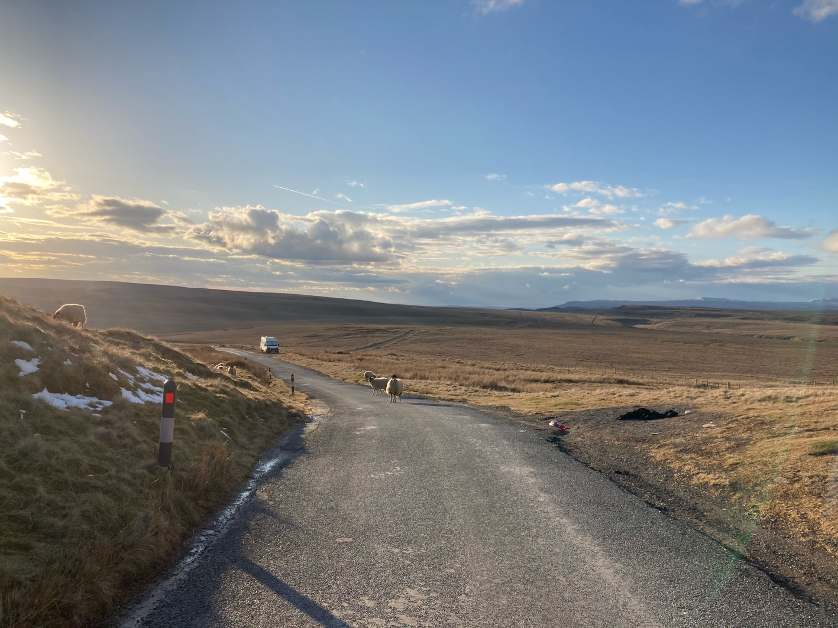
Please book with Rev Ian Pruden – ianpruden@btinternet.com by Sunday 5 June

