BEDALE AND DISTRICT METHODIST CHURCH
INVITES YOU TO

AN EVENING CONCERT
ON SATURDAY 10th JUNE 2023 at 7.30pm
FEATURING THE TALENTED YOUNG HARPIST,
LUCINDA TAYLOR
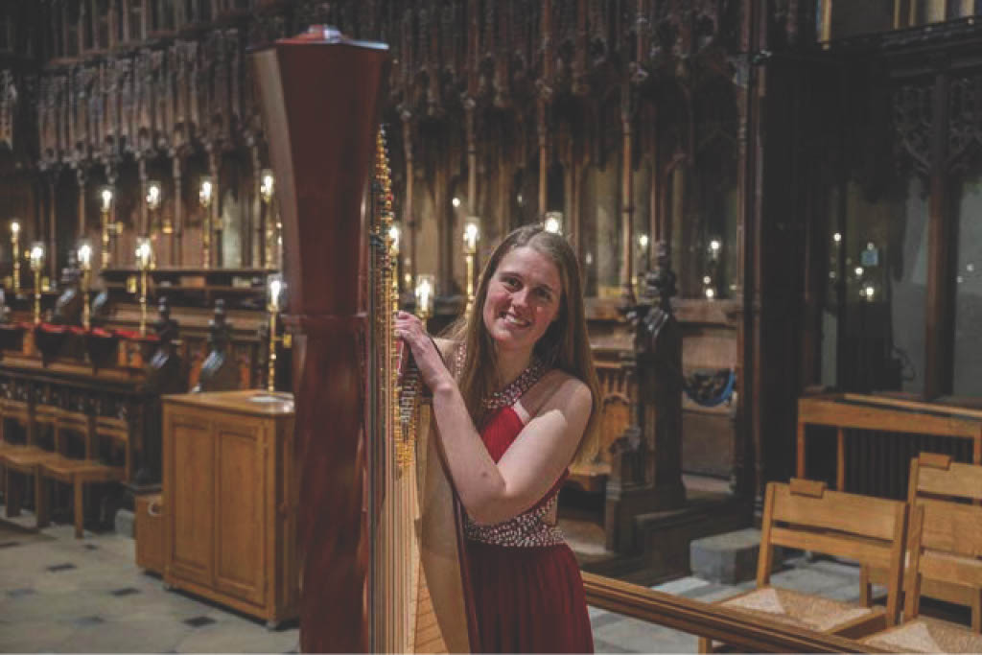
Born in North Yorkshire, Lucinda studied harp for 10 years before being awarded the Harp Scholarship at Hull University, graduating in July 2016. Since then she has become an accomplished performer, both orchestral and as a soloist. Her programme will range from classical to popular music with items from film scores and musicals you will easily recognise.
SOFT DRINKS AND NIBBLES SERVED DURING THE INTERVAL.
THERE IS NO CHARGE FOR ENTRY OR REFRESHMENTS BUT DONATIONS WILL BE WELCOME IN AID OF CHURCH FUNDS.
An experience to treasure!

