Harvest Services
St James and the Methodist Church, Grewelthorpe
Sunday 8th Oct 10.30am
Harvest Festival

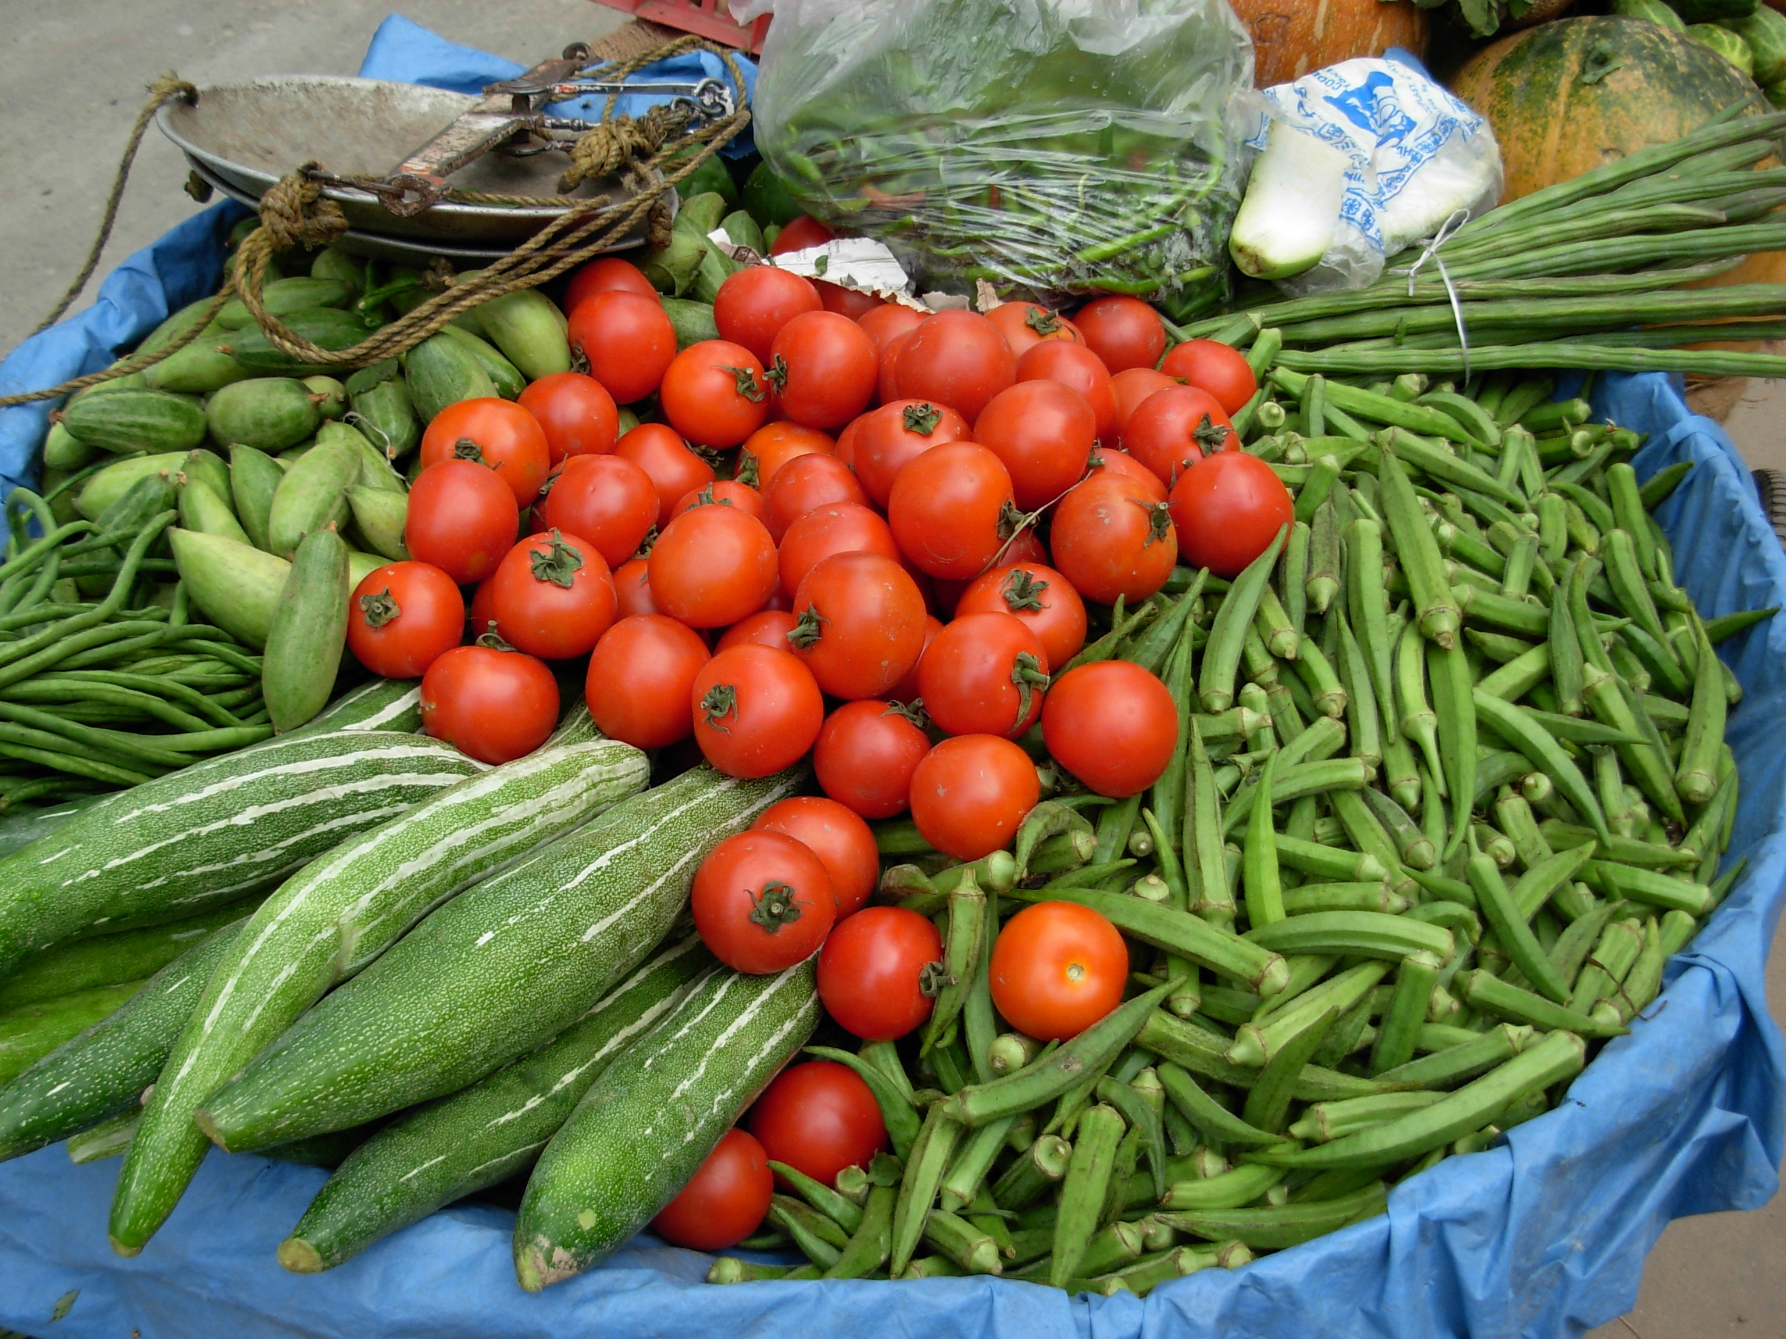
Monday 9th Oct 2.30pm
School Harvest Festival in church

Tuesday 10th Oct at 7.00pm
Methodist Harvest Thanksgiving Service
Supper, and Sale
With Rev. Sarah Caddell

Collections will be divided between church funds and the
Disaster Emergency Committee (DEC)

