
Worship at Home – Pentecost 2020
[*Including prayers from The Methodist Worship Book]

*God declares: I will pour out my Spirit on all flesh. Then everyone who calls on the name of the Lord shall be saved.
StF N°33 – In your presence
O Lord we are always in your presence. In you we live and move and have our being. You hold us in the palm of your hand and you lead us to your glory.
© 1999, Philip Jakob
*Prayer
Come, Holy Spirit, fill the hearts of your faithful people, and kindle in us the fire of your love; through Jesus Christ our Lord. Amen.

*Let us confess our sins to God.
Gracious and holy God,
we confess that we have sinned
against you and against our neighbour. Your Spirit gives light,
but we have preferred darkness;
your Spirit gives wisdom,
but we have been foolish;
your Spirit gives power,
but we have trusted in our own strength.
For the sake of Jesus Christ, your Son,
forgive our sins,
and enable us by your Spirit
to serve you in joyful obedience,
to the glory of your Name. Amen.

Let us hear God speak into our hearts.
*There is now no condemnation
for those who live in union with Christ Jesus; for the law of the Spirit of life
has set us free from the law of sin and death.

Amen. Thanks be to God.
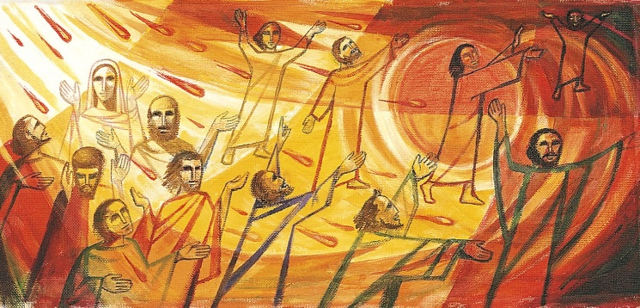
The collect of the day
*Faithful God,
you fulfilled the promise of Easter
by sending your Holy Spirit
and opening the way of eternal life
to all the human race.
Keep us in the unity of your Spirit,
that every tongue may tell of your glory; through Jesus Christ our Lord,
who is alive and Reigns with you,
in the unity of the Holy Spirit,
one God, now and for ever. Amen

StF N°400 – Wind of God, dynamic Spirit
Wind of God, dynamic Spirit,
breathe upon our hearts today;
that we may your power inherit,
hear us, Spirit, as we pray:
fill the vacuum that enslaves us –
emptiness of heart and soul;
and, through Jesus Christ who saves us,
give us life and make us whole.

Voice of God, prophetic Spirit,
speak to every heart today
to encourage or prohibit,
urging action or delay:
clear the vagueness which impedes us –
come, enlighten mind and soul;
and, through Jesus Christ who leads us,
teach the truth that makes us whole.

Fire of God, volcanic Spirit,
burn within our hearts today;
cleanse our sin – may we exhibit
holiness in every way:
purge the squalidness that shames us,
soils the body, taints the soul;
and through Jesus Christ who claims us,
purify us, make us whole.
© Michael Saward / Jubilate Hymns

Reading: Acts chapter 2, verses 1 to 21
Pentecost; The Coming of the Holy Spirit; Speaking in other languages declaring the wonders of God. What does this mean?
As we recall the Holy Spirit coming on the day of Pentecost and share in the amazement of God enabling mouths to proclaim in other languages the good news of the Kingdom of God made known through Jesus Christ, I wonder, what does this mean for us today? I wonder what the language God might be seeking to enable within us, His Church, by the power of the Holy Spirit to speak to the world.
In Paul’s letter to the Galatians we read ‘the fruit of the Spirit is love, joy, peace, patience, kindness, generosity, faithfulness, gentleness, and self-control.’ Paul reminds us that ‘those who belong to Christ Jesus have crucified the flesh with its passions and desires.’ That ‘if we live by the Spirit, let us also be guided by the Spirit.’
I believe the language God is seeking for us to speak is the fruit of the Spirit. That it is the language spoken within God’s kingdom and which the world needs to hear. In recent days and weeks, the severity of the global situation as been talked about in terms of life and death. We have been faced with the potential dangers and consequences of actions and inactions that have come into sharp focus.
The crisis of the pandemic has heightened people’s awareness to the great suffering, oppression, and injustices faced by so many across the globe. I believe that the fruit of the spirit provides a language that speaks truth to power. God’s kingdom challenges the injustice and persistent disregard for human life, showing the Way and the Truth and the life to follow.
Therefore, may we be guided by the Spirit always; that filled with the Holy Spirit our lives would speak loudly of God. May we always remain faithful witnesses, inspiring others to call upon the name of the Lord recognising that Salvation is a matter of life. Proclaiming Jesus who came so that all may have life and have it abundantly.

StF N°395 – Spirit of the living God
Spirit of the living God,
Fall afresh on me.
Spirit of the living God,
Fall afresh on me.
Break me, melt me,
mould me, fill me.
Spirit of the living God,
Fall afresh on me.
Daniel Iverson (1890-1977)
Prayers of intercession (for others)
*Gracious God,
whose Spirit helps us in our weakness
and guides us in our prayers
we pray for the church and for the world
in the name of Jesus Christ.

Let us offer our prayers,
asking,
Lord, in your mercy,
hear our prayer.

Let us say the prayer that Jesus gave us:

Our Father in heaven,
hallowed be your Name,
your kingdom come,
your will be done,
on earth as in heaven.
Give us today our daily bread.
Forgive us our sins
as we forgive those who sin against us.
Save us from the time of trial
and deliver us from evil.
For the kingdom, the power and the glory
are yours,
now and for ever. Amen.

Offering
Recalling your offering to God, however differently it may be given,
we pray:

Gracious God,
We present our offering to you recognising it came from your hand. May all that we give be received for the work in your kingdom, for your glory, honour, and praise. Amen.

StF N° 662 – Have you heard God’s voice
https://www.youtube.com/watch?v=Nn-moWOsjeA&list=PL7B5F6CDC16743FA4&index=2&t=0s
Have you heard God’s voice; has your heart been stirred?
Are you still prepared to follow?
Have you made a choice to remain and serve,
though the way be rough and narrow?

Will you walk the path that will cost you much and embrace the pain and sorrow?
Will you trust in One who entrusts to you
the disciples of tomorrow?

Will you use your voice; will you not sit down when the multitudes are silent?
Will you make a choice to stand your ground
when the crowds are turning violent?
(Chorus)

In your city streets will you be God’s heart? Will you listen to the voiceless?
Will you stop and eat, and when friendships start,
will you share your faith with the faithless?
(Chorus)

Will you watch the news with the eyes of faith and believe it could be different?
Will you share your views using words of grace?
Will you leave a thoughtful imprint?

We will walk the path that will cost us much and embrace the pain and sorrow.
We will trust the One who entrusts to us the disciples of tomorrow.

© 2008 Jacqueline G. Jones

A blessing
*The Spirit of truth lead us into all truth,
give us grace to confess that Jesus Christ is Lord, and to proclaim the word and works of God; and the blessing of God,
Spirit, Son and Father,
remain with us always. Amen.

May we go into the world in the power of the Spirit to fulfil our high calling as servants of Christ. Thanks be to God. Amen.

